Sample Doc 002

**2016**

EC2

Amazon.com

12/3/16

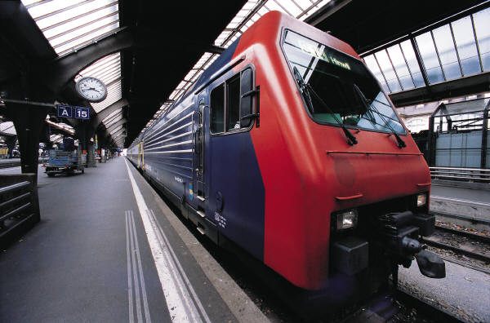

Sample doc 002

Header and Footer