Attach animation to styles:

Motivation for proposal
Currently, Impress styles control most of the visual shape appearance, but not the slideshow animation effect. Which is a pity, as the styles concept is pretty powerful inside LibreOffice, and provides a nice way to change animation settings and type for a great number of objects simultaneously. Impress comes with a collection of slide masters. They are shown in the master pages section of the Tasks pane. We can apply styles on the presentation via the slide master option available as view > Slide Master. The following items can be changed on a slide master:
- Background (color, gradient, hatching, or bitmap)
- Background objects (for example, add a logo or decorative graphics)
- Text attributes for the main text area and notes
- Size, placement, and contents of header and footer elements to appear on every slide
- Size and placement of default frames for slide titles and content
Wouldn't it be nice if custom animations could also be added to every slide by just editing one of the master slides. Currently if someone needs to apply some animation on an object, he/she has to add it manually to every slide. Although slide master works well, but it does not work for animations. My proposal is to attach a way to apply animations to slides globally via master slides so then user's effort can be reduced.

Implementation details
Since my proposal is to implement animations via Slide master. So i tried to find how the master pages worked in Impress. Master pages are used via the class SdrModel whose prototype is in include/svx/svdmodel.hxx :

151 class SVX_DLLPUBLIC SdrModel : public SfxBroadcaster, public tools::WeakBase< SdrModel >, public OutlinerSearchable
152 {
153 protected:
154 std::vector<SdrPage*> maMaPag; // master pages
155 std::vector<SdrPage*> maPages;

These are usually manipulated by SdPage objects which are used in impress by calling the SdrModel::GetMasterPage(sal_uInt16 index) function. From User interface point of view there are some classes located in sd/source/ui/sidebar like MasterPageSelector( which allows to select from the list of available master pages), MasterPageDescriptor(a collection of data that is stored for every master page in the MasterPageContainer), RecentlyUsedMasterPages etc which provide the user interface to add/edit master slides. Classes like SdStyleSheet and SdStyleSheetPool manage the original styles feature if impress.The class named MasterPageObserver observes any changes and triggers the action listeners to those changes.

The animation related code is mostly in the animations module which is manupulated by the core classes like CustomAnimationEffect, CustomAnimationPreset and CustomAnimationCloner. The Current custom animation available in impress via the format > CustomAnimation(also available in the sidebar) can provide animations per slide only. It can't make changes globally at each slide. There are other ui related classes like CustomAnimationDialog, CustomAnimationList, CustomAnimationPane etc which provide the user interface for applying animation effects on various outline levels, objects etc.

My project would be embedding the animations to the master pages so that the user can simply edit the master page and the change is reflected in the slides inheriting that master page. Although currently SdPage class has got animations(by manipulating SdAnimationInfo objects( but they apply locally only. This is a major flaw and it's one of the points that MS powerpoint has over impress.

A diagram representing what i'm trying to say is below :

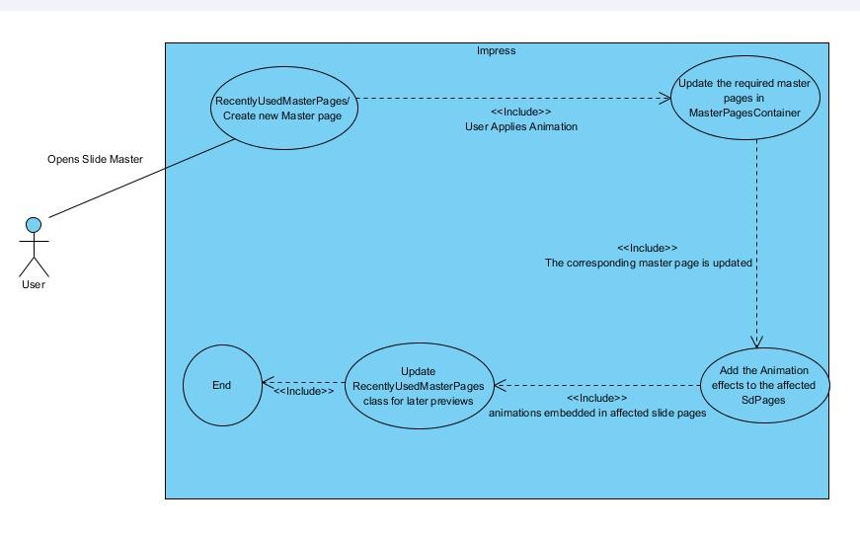
(Fig. Basic flow diagram of user applying animation on master slides)

Tentative Timeline (in weekly intervals until 2 weeks after the end of Gsoc)

April 24 – April 30: Discuss with mentor and other developers and figure out the intricacies of how the Slide Master actually works. Study the intricacies of it's design. Get deeper understanding of the requirements for the project.

May 1 – May 7: Understand the relevant classes pertaining to animations and styles and make plan to add support for animations in Slide master. Find out how master slides would store the information regarding animations.

May 8 – May 14: find out how the animations are implemented in slide objects. Also find out how already built Styles are manipulated across impress.

May 15 – May 21: Collect feedback from mentor and other developers to refine the implementation plan. Make a final workplan with no space for confusion.

May 22 – May 28: Start coding the necessary classes that might be needed to add the animation support to impress master slides as per the implementation plan.

May 29 – June 4: Code the additional classes and methods that may be required for adding support to the existing animation classes like CustomAnimationEffect, CustomAnimationPane etc.

June 5 – June 11: Implement the necessary code for support in the sidebar classes in order to get the preview of the necessary master pages.

June 12 – June 18: Integrate the code that you've written for master classes, custom animation classes etc to test whether they are working or not.

June 19 – June 25: testing, debugging , fixing bugs

+++++++++++++++++++++++++ Mid-Term Evaluation ++++++++++++++++++++++++++

June 26 – July 2: testing, debugging , fixing bugs

July 3 – July 9: Try to refactor the code you've written in order to reduce code redundancy and better performance.

July 10 – July 16: Collect feedback from mentor and other developers and make the required changes and fix more bugs. Make plan to improve the required class designs and implement high priority features.

July 17 – July 23: Improve the suggested class methods and designs. If time permits also implement the requested features as per directions given by the community.

July 24 – July 30: tidy up the previously written code.

July 31 – Aug 6: Write Documentation.

Aug 7 – Aug 13: Buffer time

Aug 14 – Aug 20: Buffer time

Required Skills:
C++, reading other's code

Difficulty:
hard

Potential Mentors:
Thorsten Behrens, IRC: thorsten, mail: thb@documentfoundation.org
Katarina Behrens, IRC: bubli, mail: bubli@bubli.org

About Me :
I am Rohan Kumar, 4rth year student of Software Engineering in UIET, Panjab University, Chandigarh. I was introduced to programming in my first year of college. I was introduced to linux when my parents bought me a laptop which had Ubuntu installed on it. Linux has taught me programming, the way i used to find a fix for a problem gives a way to learn new things. Since i've been using linux LibreOffice has been my partner while preparing college assignments, ppts and i love it. I just want to give something back to open source community which has given me so much.

Email : rohankanojia420@gmail.com
Freenode irc nick : Rohan_Kumar
Location : Chandigarh, India (UTC + 5:30)
github profile : https://github.com/rohanKanojia

