A updated and incomplete article of Development/Create new dialog in Impress - The Document Foundation Wiki (2013) - by Jingze Xu 2023

create and place .ui file
Open the glade tool.

glade

Create a new file，click GtkDialog in Toplevels column to create a dialog.
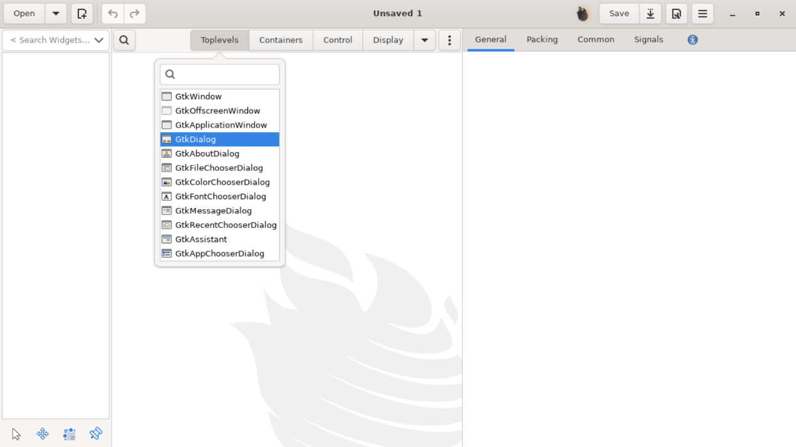

On the left panel, click GtkButtonBox，the corresponding area will be highlighted。Click GtkButton in Control column，then click GtkButtonBox area and place the button into it。
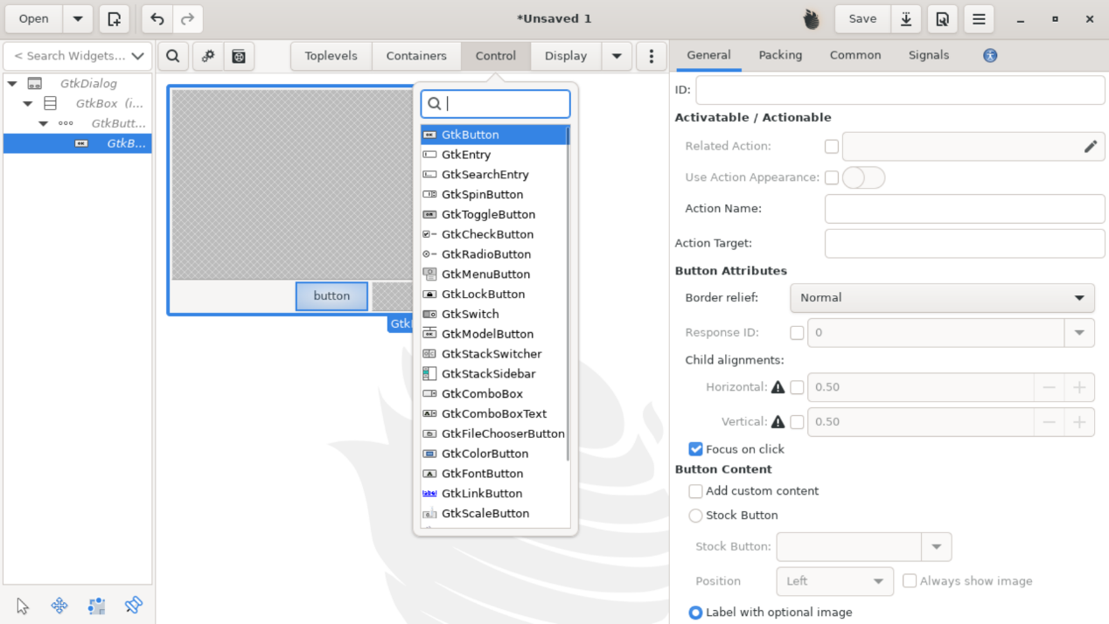
Set ID for the buttons. We set the left button’ID to “ok_btn”, and the right button’s ID to “cancel_btn”. We will use them later. Next, check stock button and choose ok/cancel in the menu.

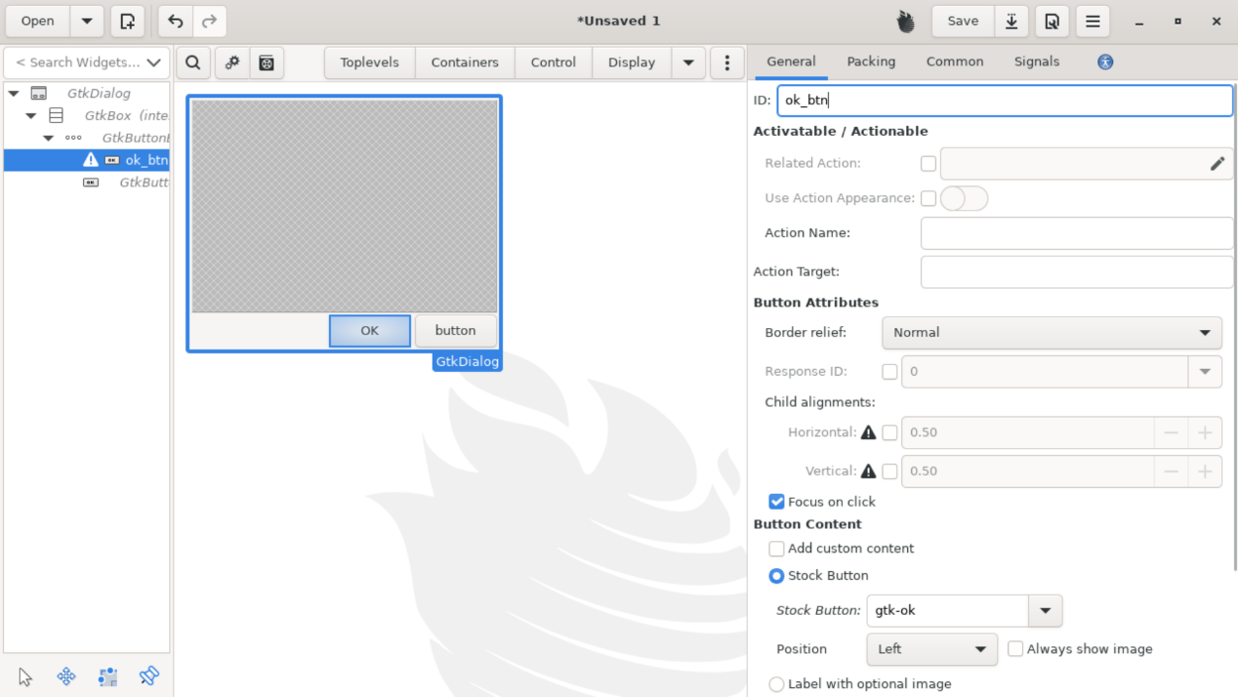

Name other components. Set GtkDialog’s ID to HelloDialog, we will use it later.
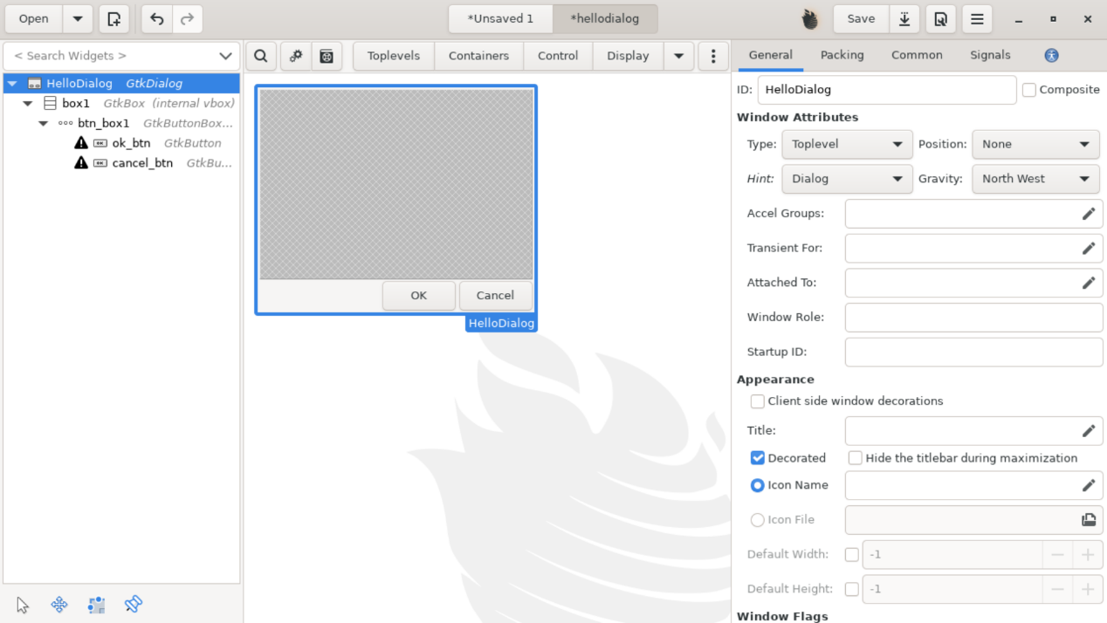

code for the dialog
HelloDialog.hxx
#pragma once

#include "tools/link.hxx"

#include <vcl/weld.hxx>

namespace sd
{

class SdHelloDialog: public weld::GenericDialogController
{

public:
SdHelloDialog(weld::Window* pWindow);
virtual ~SdHelloDialog() override;

private:
std::unique_ptr<weld::Button> m_xCancelBtn;
std::unique_ptr<weld::Button> m_xOKBtn;
DECL_LINK(CancelHdl, weld::Button&, void);
DECL_LINK(OKHdl, weld::Button&, void);
};

} // end of namespace sd

HelloDialog.cxx

#include "HelloDialog.hxx"
#include "strings.hrc"
#include "sdresid.hxx"

#include <vcl/weld.hxx>

namespace sd
{

SdHelloDialog::SdHelloDialog(weld::Window* pWindow)
: GenericDialogController(pWindow, "modules/simpress/ui/hellodialog.ui", "HelloDialog")
, m_xCancelBtn(m_xBuilder->weld_button("cancel_btn"))
, m_xOKBtn(m_xBuilder->weld_button("ok_btn"))
{
m_xCancelBtn->connect_clicked(LINK(this, SdHelloDialog, CancelHdl));
m_xOKBtn->connect_clicked(LINK(this, SdHelloDialog, OKHdl));
}

SdHelloDialog::~SdHelloDialog()
{
}

IMPL_LINK_NOARG(SdHelloDialog, CancelHdl, weld::Button&, void)
{
m_xDialog->response(RET_CANCEL);
}

IMPL_LINK_NOARG(SdHelloDialog, OKHdl, weld::Button&, void)
{
m_xDialog->response(RET_OK);
}

} // end of namespace sd

Place the .hxx and .cxx file in sd/source/ui/dlg/.

modify a series of files

- sd/uiconfig/simpress/menubar/menubar.xml

<menu:menuseparator/>
<menu:menuitem menu:id=".uno:Grid"/>
<menu:menuitem menu:id=".uno:NavigationBar"/>
</menu:menupopup>
</menu:menu>
<menu:menuseparator/>
<menu:menuitem menu:id=".uno:HelloDialog"/>
</menu:menupopup>
</menu:menu>
<menu:menu menu:id=".uno:FormatMenu">
<menu:menupopup>
<menu:menu menu:id=".uno:FormatTextMenu">
<menu:menupopup>
<menu:menuitem menu:id=".uno:Bold"/>
<menu:menuitem menu:id=".uno:Italic"/>

- sd/inc/app.hrc

#define SID_PREVIEW_STATE (SID_SD_START+329)
// FREE
#define SID_SLIDE_TRANSITIONS_PANEL (SID_SD_START+334)

// test
#define SID_HELLODIALOG (SID_SD_START+335)

#define SID_PHOTOALBUM (SID_SD_START+336)
#define SID_REMOTE_DLG (SID_SD_START+337)

- sd/sdi/drviewsh.sdi

SID_PHOTOALBUM
[
ExecMethod = FuTemporary ;
StateMethod = GetMenuState ;
]
SID_HELLODIALOG
[
ExecMethod = FuTemporary ;
StateMethod = GetMenuState ;
]
}

shell DrawViewShell
{
import ImpressEditView;
}

- sd/sdi/sdraw.sdi

SfxVoidItem PhotoAlbumDialog SID_PHOTOALBUM
()
[
AutoUpdate = FALSE,
FastCall = TRUE,
ReadOnlyDoc = FALSE,
Toggle = FALSE,
Container = FALSE,
RecordAbsolute = FALSE,
RecordPerItem;

AccelConfig = TRUE,
MenuConfig = TRUE,
ToolBoxConfig = TRUE,
GroupId = SfxGroupId::Options;
]

// testing
SfxVoidItem HelloDialog SID_HELLODIALOG
()
[
AutoUpdate = FALSE,
FastCall = TRUE,
ReadOnlyDoc = FALSE,
Toggle = FALSE,
Container = FALSE,
RecordAbsolute = FALSE,
RecordPerItem;

AccelConfig = TRUE,
MenuConfig = TRUE,
ToolBoxConfig = TRUE,
GroupId = SfxGroupId::Options;
]

- sd/source/ui/dlg/sddlgfact.hxx

// test
virtual VclPtr<VclAbstractDialog> CreateSdHelloDialog(weld::Window* pWindow) override;

// For TabPage
virtual CreateTabPage GetSdOptionsContentsTabPageCreatorFunc() override;
virtual CreateTabPage GetSdPrintOptionsTabPageCreatorFunc() override;
virtual CreateTabPage GetSdOptionsMiscTabPageCreatorFunc() override;
virtual CreateTabPage GetSdOptionsSnapTabPageCreatorFunc() override;

};

- sd/source/ui/dlg/sddlgfact.cxx

// test
#include "HelloDialog.hxx"

VclPtr<VclAbstractDialog> SdAbstractDialogFactory_Impl::CreateSdPhotoAlbumDialog(weld::Window* pParent, SdDrawDocument* pDoc)
{
return VclPtr<SdAbstractGenericDialog_Impl>::Create(std::make_unique<sd::SdPhotoAlbumDialog>(pParent, pDoc));
}

// test
VclPtr<VclAbstractDialog> SdAbstractDialogFactory_Impl::CreateSdHelloDialog(weld::Window* pWindow)
{
return VclPtr<SdAbstractGenericDialog_Impl>::Create(std::make_unique<sd::SdHelloDialog>(pWindow));
}

- sd/inc/sdabstdlg.hxx

virtual VclPtr<VclAbstractDialog> CreateSdPhotoAlbumDialog(weld::Window* pWindow, SdDrawDocument* pDoc) = 0;

// test
virtual VclPtr<VclAbstractDialog> CreateSdHelloDialog(weld::Window* pWindow) = 0;

protected:
~SdAbstractDialogFactory() {}
};

- sd/source/ui/view/drviews2.cxx

case SID_PHOTOALBUM:
{
SdAbstractDialogFactory* pFact = SdAbstractDialogFactory::Create();
vcl::Window* pWin = GetActiveWindow();
ScopedVclPtr<VclAbstractDialog> pDlg(pFact->CreateSdPhotoAlbumDialog(
pWin ? pWin->GetFrameWeld() : nullptr,
GetDoc()));

pDlg->Execute();
Cancel();
rReq.Ignore ();
}
break;

// test
case SID_HELLODIALOG:
{
SdAbstractDialogFactory* pFact = SdAbstractDialogFactory::Create();
vcl::Window* pWin = GetActiveWindow();
ScopedVclPtr<VclAbstractDialog> pDlg(pFact->CreateSdHelloDialog(
pWin ? pWin->GetFrameWeld() : nullptr));

pDlg->Execute();
Cancel();
rReq.Ignore ();
}
break;

- sd/Library_sdui.mk

add “sd/source/ui/dlg/HelloDialog \” under “$(eval $(call gb_Library_add_exception_objects,sdui,\”.

- sd/UIConfig_simpress.mk
add “sd/uiconfig/simpress/ui/hellodialog \” under “$(eval $(call gb_UIConfig_add_uifiles,modules/simpress,\”.

- officecfg/registry/data/org/openoffice/Office/UI/DrawImpressCommands.xcu

<node oor:name=".uno:PhotoAlbumDialog" oor:op="replace">
<prop oor:name="Label" oor:type="xs:string">
<value xml:lang="en-US">Photo Album</value>
</prop>
<prop oor:name="Properties" oor:type="xs:int">
<value>1</value>
</prop>
</node>
<node oor:name=".uno:HelloDialog" oor:op="replace">
<prop oor:name="Label" oor:type="xs:string">
<value xml:lang="en-US">Open Hello Dialog</value>
</prop>
<prop oor:name="Properties" oor:type="xs:int">
<value>1</value>
</prop>
</node>

rebuild and run
make sd

make

instdir/program/soffice --impress

