Introduction

This document describes the background of the work performed to improve the latency estimation and latency stability of module-loopback which is part of pulseaudio. The current module-loopback code implements only a very basic scheme for the control of the end-to-end latency which is not sufficient in many situations, so the latency controller has been replaced by a combination of a modified P-controller and a controller for adaptive re-sampling.
Since the delay estimation in alsa-source and alsa-sink is not exact enough to make use of the full potential of module-loopback, the corresponding code has also been replaced by a different approach.
The first chapter of the document explains the theoretical background for the calculation of a time conversion factor between different time domains as used in alsa-source and alsa-sink. It has been separated from the actual implementation, because it covers the general idea in more detail than required for the implementation.
The second chapter gives an overview over the two types of filters that are common to module-loopback, alsa-sink and alsa-source, while the following chapters describe the implementation and the results.

Iterative calculation of time conversion factor (β) for delay estimation

For a given number of samples, the corresponding time in the source and sink domain is given by

If we define time and rate conversion factors β and α, we get the following relationships:

The following calculations are performed in the source time domain, so the source frequency is assumed to be the nominal frequency of the device. „Source“ can be replaced by „System“ (and „Sink“ by „Source“ if appropriate) when only the relationship to the system time needs to be calculated for a single sink or source. Throughout the document, the subscripts t refers to the time of the current iteration, while t-1 indicates the previous iteration.

In most situations the time conversion factor β_{t} at a given time t can be obtained more or less directly, but the raw observations contain too much error to achieve a stable estimation of the frequency difference or for extrapolation of the device time, even if some filtering is applied. To circumvent this problem, an iterative approach can be used by calculating the frequency difference as:

Assuming that β_{t} = β for all t, we get for the first iterations:

This is the beginning of a geometrical series:

The limes of a geometrical series is

so the series converges to the frequency difference defined above.

Alternatively for delay estimation (device time extrapolation) we can eliminate the dependency on the source frequency and compute

instead. Solving as above yields:

1 – β is near zero, this means that small absolute errors of β will lead to a high relative error of the computed result. Additionally the convergence behavior of the series changes depending on the sign of 1 – β. A more robust result can be obtained when β is shifted by a constant c with 0 ≤ c < 1:
and

Solving again as above gives
and

The new series will converge without any additional filtering when c is chosen properly, though the results will still be quite noisy.

Filtering

There are two types of filters that are used within the code which are described below in detail.

1) Simple first order low pass filter

The implementation of the first order low pass with output signal y and input signal x can be expressed as:

See also https://en.wikipedia.org/wiki/Low-pass_filter. If T denotes the time between two subsequent iterations of the filter and with, the coefficient γ can be written as:

For filters with constant cut-off frequency, γ is computed every iteration, so if T is not constant, γ may vary as well. In some situations filtering should be based on the number of iterations instead of the elapsed time, then a constant γ is used. For simplicity, the code implements a second order filter by chaining two first order filters.

2) Kalman filter

The theory behind the Kalman filter is rather complex (see for example https://en.wikipedia.org/wiki/Kalman_filter ). The basic idea is to compare the measured values against a model and construct the output signal as a weighted average of the measured value and the prediction. The weights are determined by the variances of predicted and measured values.
For the one dimensional case where we have an input signal x with varianceand a prediction y with variancethe output signal z of the filter is calculated as

The variance of the output signal is

For the next iteration, the prediction y_{t+1} is based on z_{t} and the used model, so the new variancecan be computed fromand from the uncertainty introduced by the model:

The code assumes that the quality of the prediction depends on the variance of the measured values and estimates the model variance to

The constant k is necessary to ensure that for small variances of the input series the measured values are preferred over the prediction. k is set to 200 in module-loopback and to 500 for alsa sink and source. Because the variancecannot be determined in advance, it is computed as a running average of which is probably not completely correct from a mathematical perspective, but still delivers good filter quality.
The overall quality of the filter strongly depends on the validity of the underlying model.

Implementation of delay estimation in alsa-sink and alsa-source

The latency reports of alsa-sink and alsa-source are based on the difference between the amount of audio that was written to or read from the alsa buffer and the amount of audio that has already been played or recorded. All latencies are given in the sound card time domain and can be written as

at any point in time. n_{written} and n_{read} are updated whenever data is written or read, but the card time changes continuously and has to be computed from the system time. For this purpose a relationship between system time and sound card time needs to be established. The code assumes that this relationship is linear, so that the sound card time can be expressed as. For the calculation of β the conditions can been chosen so that t_{Offset} = 0 by using the moment when the first audio has been played or recorded. Because the moment cannot be observed directly, the time when the first changes in the alsa buffer occur is chosen as an origin. The corresponding system time t₀ and the sample count n₀ are saved and all times and sample counts are calculated relative to those offsets. n₀ contains all samples that have been recorded or played at t₀, that implies that on the source side the reported alsa delay is part of n₀.
Keeping n₀ and t₀ constant has two major disadvantages. First the latency takes rather long to stabilize, times of up to 5 minutes have been observed with this approach. The second problem is the reaction time to sudden changes in the sample rate. If module-loopback has been running for a long time, compensating a change in the sample rate can take several minutes with a very slow drift towards the steady state. To avoid these problems, n₀ and t₀ are recalculated on every iteration, starting after 15 seconds of run time according to:
This means that t – t₀(t) is kept

near to 15s and n₀(t) is calculated from the previous value using the average gradient of n(t) over the last 15 seconds. β is then estimated as the limes of a geometrical series as outlined in the first chapter. A value of c = 0.5 is considered optimal for the calculation of ε to achieve similar conditions for β < 1 and β > 1 while reducing the impact of errors in the measured card time as far as possible. With the choice of c, the series will converge for all sample rates that are less than 50% away from the nominal rate, because |1.5 – β_{t}| < 1 means 0.5 < β_{t} < 2.5. This should be more than sufficient for all practical use. Whenever data is written to or read from the alsa buffer the seriesand β(ε) are computed according to

t_{Sink or Source} in the equation above is derived from n_{written or read} and the delay reported by the alsa driver. To further reduce noise, a 2nd order low pass filter is applied for the geometrical series and an additional first order low pass is used for the calculation of β. The subscript of the low pass denotes the time constant of the filter. It is more effective to filter the series, but this also slows down convergence. With 2s time constant for ε and 15s for β(ε) the mean value of the measured latency converges to around ±100 μsec of the final value within less than 30 seconds. Full stability is reached after less than 1 minute. The choice of the filter constants is a trade-off between convergence time and noise reduction.
The Kalman filter is used as a pre-filter for the card time values. The underlying model is simple, the predicted value is given by. This choice is only appropriate, if β(ε) is already near its final value. If the Kalman filter is applied while the series is not near the steady state, convergence will be slowed down drastically. To avoid this, a measure δ² for the convergence state of β(ε) is introduced as
where t_{iteration} is the time in μs between subsequent

iterations. The Kalman filter will only be applied when δ² < 100, which means that the average change rate of β(ε) has dropped below approximately 10⁻⁶ per second.

Now that β is known, t_{Offset} also has to be considered. On the source side t_{offset} evaluates to, because the signal starts with the first sample that is recorded, even if there is a delay between snd_pcm_start() and the beginning of the recording. At t=t₀ the latency is the delay reported by alsa (l_{alsa}) and the number of samples is n₀ = n_{read}(t₀) + n(l_{alsa}) With this the resulting latency for the source can finally be estimated to

On the sink side however, the audio flow starts even before snd_pcm_start(), because at the time of the call, the alsa buffer has already been filled with audio. At the time t_{start} when snd_pcm_start() is called, the delay is well known: n_{written} is the number of samples that have been written to the alsa buffer. At the time t_{0,} as defined above, the first audio has left the alsa buffer. At this time n₀ = n_{written}(t₀) – n(l_{alsa}) samples have already been delivered to the DAC while n_{written}(t₀) samples have been written to the alsa buffer. Meanwhile the time t₀ - t_{Start} has elapsed. During this time, only n₀ samples have reached the DAC. This leads to a delay of
Ideally this part of the latency is zero, but in practice this is not the case.

Because this is the delay of the first sample and the samples are isochronous, all following audio will be affected by it. Additionally there are still n_{written} – n₀ samples in the buffer which contribute to the delay. The total latency at the moment when the first audio has been played can therefore be expressed as

For the first stream that connects to the sink, the total latency at time t_{System} is then given by

Pulseaudio keeps the number of samples in the sink constant until audio is flowing. This means, that the delay of the top sample in the buffer gets smaller until playback is started. Therefore the initial delay term is only relevant for the first stream and should not be included in the latency reports of the sink. With this, the reported sink latency finally becomes

For USB sinks, a workaround is required because the latency reported by alsa is corrected by the driver shortly after startup. This means, that initially the values are 2 – 5ms too large or too small and suddenly change to the correct values within the first 2 seconds after the sink has been started. From that time on the latencies remain consistent. Since this is a one-time event and represents no real change in the latency, it can be dealt with quite easily by correcting t₀ to compensate the jump and adding back the difference as offset to the latency. If the USB sink is run in batch mode, the offset is smaller and in the range between 1ms and 2ms.
The event can be detected reliably, because normally the difference between system time converted to card time and the measured card time is less than 1ms. If the jump does not take place within the first 5 seconds, the workaround is disabled to avoid false triggers. If the change is not detected for some reason, it will take longer to reach the equilibrium state.

Implementation of the latency controller im module-loopback

The latency controller in module-loopback works by measuring the current end-to-end latency and adjusting the sample rate of the sink input until the configured latency is reached. Additionally, adaptive re-sampling is used to maintain the configured latency once it has been adjusted. A modified P-controller is responsible to correct the end-to-end latency while adaptive re-sampling is implemented using a direct method outlined further below. Because the two parts of the controller are mainly independent, they will be treated separately here.

1) Determination of end-to-end latency and latency prediction

The end-to-end latency of module-loopback is composed of sink and source latency and the amount of audio buffered in various places. Following buffer components contribute to the total latency:

a) module-loopback memblockq
This is the part of the buffer that is under direct control of module-loopback and can be adjusted to achieve and maintain the desired end-to-end latency. Samples will be consumed at the rate of the sink input and added at the rate of the source output.

b) Delay memblockq of source output and render memblockq of sink input
Samples in those buffers are added or consumed at the rate of the source or sink. This must be taken into account when the delay is calculated.

c) module-loopback message queue
At any time, there may be audio that has already been sent by the source but has not been received by module-loopback. To keep track of this, module-loopback uses the variables send_counter and recv_counter. Samples in the message queue are spaced at the rate of the sink input.

Because the sample counts and latencies are captured as separate snapshots on the source and sink side, the delay between the two has to be taken into account. The sink input snapshot is taken first to minimize delay.
During the sink input snapshot, the number of samples in the memblockq, the sink latency, the recv_counter, the number of samples in the render memblockq and a time stamp are recorded. Because the contents of the render memblockq is already on the sink side from the perspective of module-loopback, the corresponding delay is added to the sink latency and not captured as a separate number. Similarly the source output snapshot records source latency together with the delay caused by the delay memblockq, as well as the send_counter and a time stamp. In the further discussion, sink and source latency always include the delays introduced by the associated memblockq's.
With l_{p} and l_{r} being the sink and source latencies respectively, n_{q} the number of samples in the loopback memblockq, f_{SinkInput} the sink input sampling frequency, t_{SourceSnap}, t_{SinkSnap} the snapshot time stamps, andthe total latency can be computed as:

This is a simplification, because it does not take into account, that the latencies are measured in different time domains. The first term is in the source domain, the next two in the sink domain and the remaining terms are in the system time domain. Because the differences between the time domains are small, the equation above can still be used as a valid approximation. The goal of the regulation is to achieve the requested latency at the optimum rate needed to maintain the current latency, therefore the latency at the optimum rate is calculated:

f_{Optimum} is the sum of the nominal module-loopback frequency f₀ and the frequency difference Δf between source and sink. The difference between the Kalman filtered latency (see filtering chapter) at optimum rate and the configured latency is used as input for the P-controller (see below).

The latency controller is executed at fixed time intervals of t_{adjust} that can be configured on the command line. Because these time intervals are not exactly constant, the code uses an average value instead.
If the current end-to-end latency and the sink input sampling rate for the next adjust time are known, the next expected latency can be predicted. The prediction is needed as model input for the Kalman filter. For these calculations the sink time domain will be used. At f_{SinkInput} = f_{Optimum}, samples are leaving the memblockq at the same rate as they are entering, therefore the source output frequency is f_{Optimum} in that domain. Samples are leaving the memblockq at a frequency of f_{SinkInput}(t+1) The resulting change in the number of samples between subsequent iterations is

f_{SinkInput}(t+1) stands for the sink input rate that will be used for the next interval. If the sink input frequency differs from the current value during the following iteration, this will have an effect on the latency introduced by the samples in the memblockq and the message queue because they are supposed to be consumed at the sink input frequency. With this, the next expected latencies can be expressed as

Unfortunately pulseaudio has the limitation that sample frequencies can only be integers, therefore the latency changes caused by the fractional amount of the frequency difference cannot be completely compensated. With defining the equilibrium frequency as the next latency at this frequency is The code implements slight filtering

by calculatinginstead. Now that the current and next

latency are known, the latency controller can be considered in detail.

2) Adaptive re-sampling

Adaptive re-sampling in module-loopback uses a direct and very simple approach. The method described below can be used whenever the latencies at a given time can be determined. In absence of noise it delivers the exact frequency difference between the cards after only one iteration. The input for the adaptive re-sampling controller is the differencebetween subsequent latency reports. It is important for the following calculations to exclude the impact of different sink input rates on the samples in the buffer (see equation for l_{next}), so l_{total} needs to be estimated at the current sample rate for both times.
On the other hand, the same latency difference can be computed from the known sink input and source output frequencies and the time between the iterations. In the sink time domain, the source is running at a frequency ofThe latency controller has changed the sink input frequency toduring the last iteration. So Δl is given by

The controller then computes

Replacing Δl in the equation with the expression above shows that he inner terms immediately yield the wanted frequency difference. The frequency correction Δf_{SourceSink}(t) is then added to the output of the P-controller.

3) P-Controller

module-loopback uses a modified P-controller to adjust the end-to-end latency to the desired value. The starting point is a standard P-controller optimized according to the Ziegler-Nichols method (see https://en.wikipedia.org/wiki/Ziegler%E2%80%93Nichols_method), which would set a rate to correct the whole latency error within one t_{adjust}.
For the derivations below it is assumed, that source and sink use the same clock source and the same base frequency f₀, because the adaptive re-sampling controller already accounts for the difference between the time domains. At the time t = 0 with initial latency l₀, there are n₀ = f₀l₀ samples in the system. When the frequency is increased by Δf for an interval t_{adjust}, the resulting number of samples will beThe configured latency l_{configured} should be reached at the base frequency f₀, this gives

With this, the classical P-controller can be written as

The equation above is only valid when the latency difference Δl is evaluated at f₀, therefore the input of the controller is the difference between the configured latency and the current latency at the optimum rate:
The controller is optimized according to Ziegler-Nichols, because doubling the last term in the brackets would correct the latency difference to the negative of the current value, which would induce stable oscillations.
The simple P-controller has however several disadvantages. First, if the latency difference is too large, the output values can become negative or larger than the maximum sampling frequency that pulseaudio supports. To avoid this situation and to be able to adjust even large latency deviations without much impact on the sampling rate, a modification has been implemented that limits the output of the controller to f₀ ±1%. The value of 1% was chosen because the frequency deviation should not be too audible. The correcting term is calculated as
and the controller equation is modified to

For small Δl, ζ will be near 1 and the controller will act

like the unmodified P-controller, while for large Δl the last term in the brackets will converge to ±0.01, depending on the sign of Δl, thereby limiting the controller output. The side effect of the definition of ζ is, that after the first iteration, the correction steps generated by the controller will always be smaller than 2.01‰ of the base rate. The current module-loopback code also limits a single correction step to 2‰.

To demonstrate the step size of the controller, two subsequent iterations are considered. It is

From the controller definition follows that the relative difference between subsequent frequencies can be written as

Now we can use that |Δl_{n+1}| ≤ |Δl_{n}| because the controller is adjusting, this means

Together with the expression for Δl_{n+1} and the substitutionthe relative difference evaluates to

It needs to be shown, that the relative frequency difference is smaller than some limit K:

On the other hand it is
Replacing x in the equation above and reordering leads to

Resolving absolute values and substituting

z = λ ± β leads to

Now it remains to be shown that this function is always larger than zero for some value K_{max}. f(z) has one relative minimum and because z ≥ λ and f(λ) > 0, only the case where z_{min} > λ is interesting.
The previous condition is true if f(z_{min}) = 0 for K = K_{max}, which gives

Reordering and substituting finally yields

This could be solved analytically, but because p << 1

a linear approximation is sufficient, which leads to
This proves, that the step size for λ = 0.01 cannot be larger than about 2.01‰ of the base frequency. This is however not valid for the first iteration, the initial step can still be as large as λ.
To limit the initial steps to 2‰ as well, a second controller similar to the first is implemented which calculates a frequency that is not more than 2‰ away from the previous frequency.

The code chooses f_{p2} over f_{p} if f_{p2} is nearer to the base frequency. The condition is only true during the initial steps and ensures a smooth transition between the two controllers.

One more modification to f_{p} is necessary, because the controller is too sensitive in certain situations. Therefore a controller weight 0 < w ≤ 1 has been introduced and the final equation for the P-controller becomes

The minimum controller weight is computed from a configurable adjust threshold t_{threshold} so that a deviation from the target latency by t_{threshold} will lead to a sampling frequency change of 1Hz. Because of rounding, a change of 0.5Hz in the controller output is sufficient to trigger a change in the sampling frequency. Therefore w_{min} can be estimated from the controller equation to:

To achieve quick stabilization, the weight will only be applied when the frequency is already within 2‰ of the base frequency. Additionally a dependence on the difference to the target latency was introduced, so that the effective weight is estimated to

The minimum weight is only reached when the latency difference is less or equal than the adjust threshold.

Methods

The majority of the work was performed on a system equipped with a HDA (ALC888) sound card and a cheap C-Media USB headset adapter. A Bitscope Micro Dual USB oscilloscope connected to another system was used as signal source and for recording of the input and output signal. Usually a 1 kHz rectangle signal was applied to the input of the HDA or USB device and was also used as a trigger source for the oscilloscope. Lower frequencies were necessary if the resulting latency ranges were so large that they could not be displayed properly with a time base of 100 μs.
The corresponding output signal was measured on the second channel of the oscilloscope. The overlay mode of the oscilloscope allows for a long term observation of the latency stability. The time range that is covered by the movement of the edge of the output signal was taken as a measure for the latency inaccuracy.

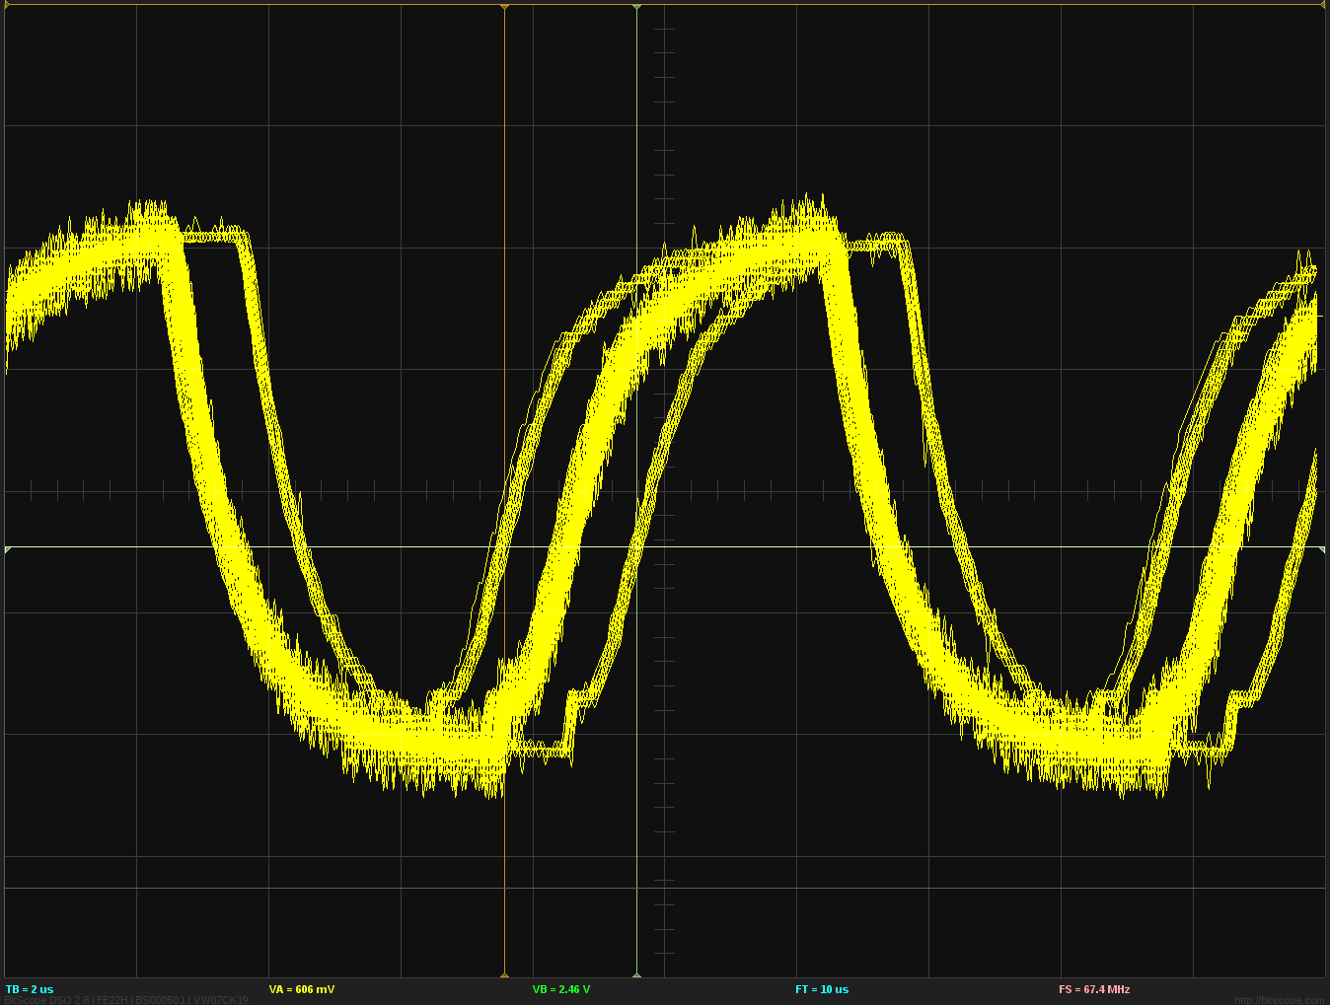 | Unfortunately the signal source proved to be not completely stable. This could be made visible by running the source at a high frequency of 100kHz and recording the signal. The image on the left shows the period time instability of about 1μs. It is also obvious, that the period time jumps between discrete values. These period time changes seem to affect multiple periods in a row and add up to around 7 μs, so that in the HDA to HDA recordings multiple discrete lines spaced by 7 μs are visible. The effect is even more pronounced at long latencies of several seconds where up to 40 or 50 lines can be observed.

Results

The table below shows example results for the original code, the new module-loopback code with the current smoother and the new module-loopback code with the new smoother. Recording time was one hour in all cases with the same parameters (200ms requested latency, 1s adjust time). Input and output were on the same USB device, the frequency difference between sink and source was around 3.2 Hz.
Original code | 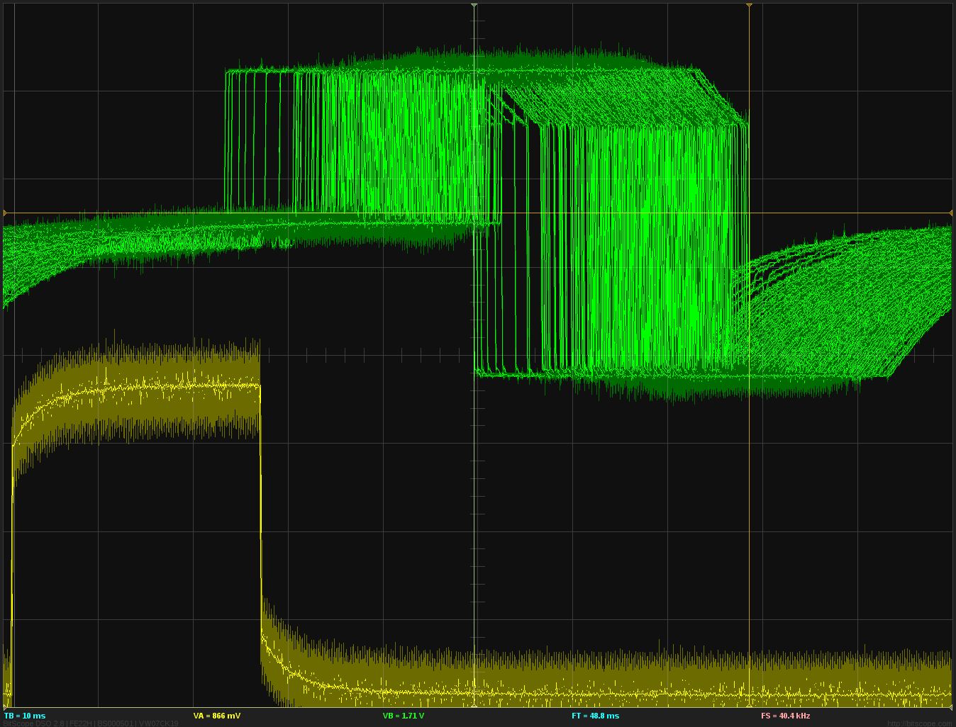 | The original code shows a latency jitter of 29 ms. Additionally the equilibrium value was around 240 ms instead of the requested 200 ms. Time base of the screen shot is 10 ms and a frequency of 10 Hz is used because the extremely large latency jitter could not be made visible otherwise.
New module-loopback with old smoother | 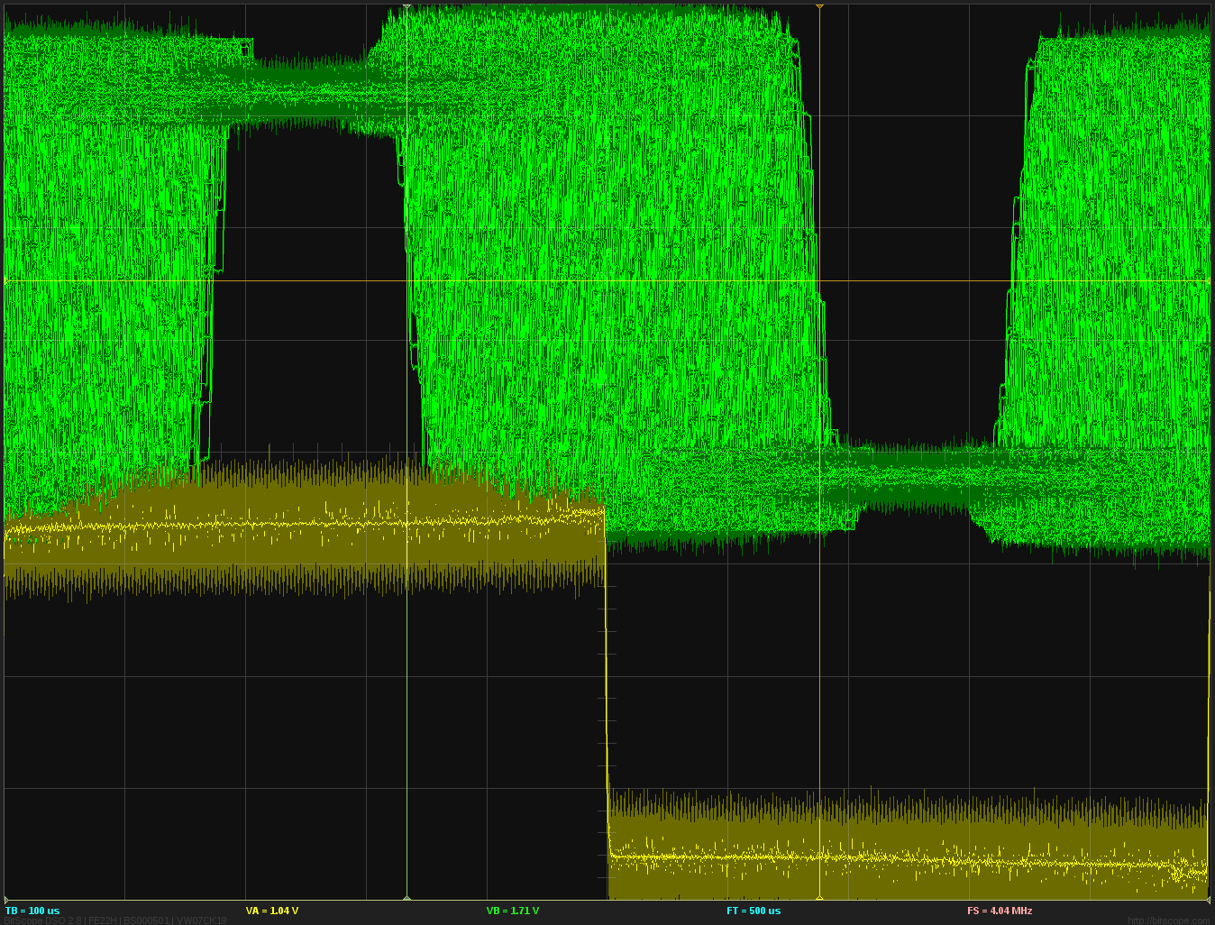 | Using the same parameters and the new module-loopback code, the resulting stability is around 340μs, which is about a factor of 85 better than the original. Time base is 100 μs and 1kHz input frequency was used.
New module-loopback with new smoother | 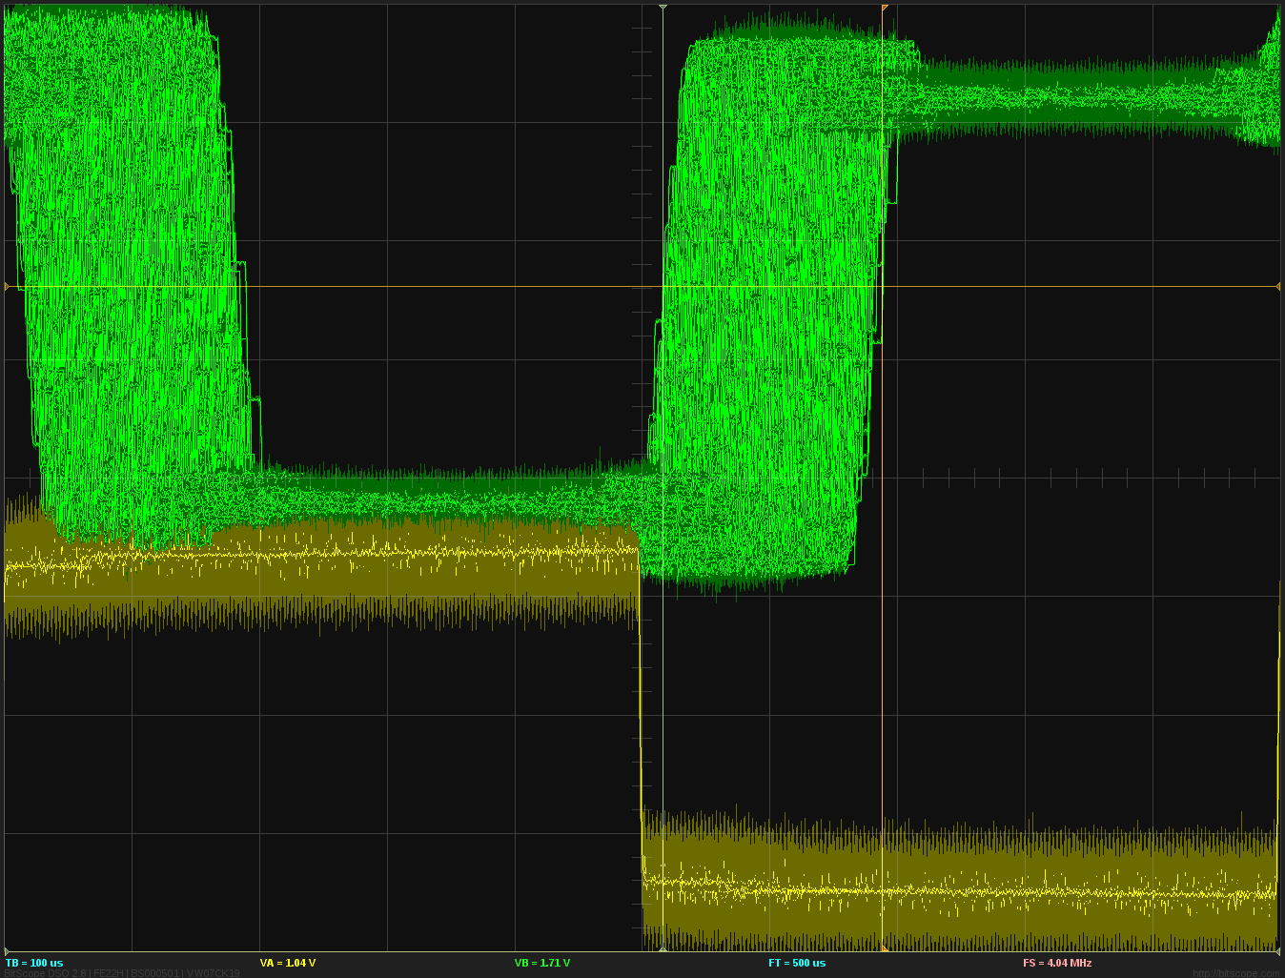 | Using the new smoother code again halves the latency jitter to around 170μs. This gets more pronounced for shorter latencies, at 50 ms the improvement is about a factor of 5 (see further results below).

To compare the new and old smoother code in some detail, the results for different latencies are shown in the table below. Recordings are for 10 minutes with 1 minute of stabilization. Time base of the recordings is 100μs for 50 ms and 200 ms and 200 μs for 2000 ms and 20000 ms. Input frequency is 1 kHz for the first two and 500 Hz for the other two. The left column in the table indicates the requested latency and the width of the latency jitter. For all recordings with the old smoother and for 2000 ms and 20000 ms with the new smoother, the adjust threshold had to be set to 200 μs to avoid oscillations. The 2000 ms and 20000 ms cases show similar results, because the latency jitter caused by the source instability masks the instability introduced by module-loopback. At those long delay times even moving the cursor in the application or saving the image will cause apparent latency changes (see for example the 20000 ms recording with the old smoother).
The stabilization time using the new smoother is longer than with the old code. While the old code reaches the equilibrium after around 20 – 30 seconds, it can take up to a minute for the new code. Nevertheless the new code will be in the same range as the old smoother within 20 – 30 seconds.

 | Current smoother | New smoother
50 ms  345 / 75 μs | 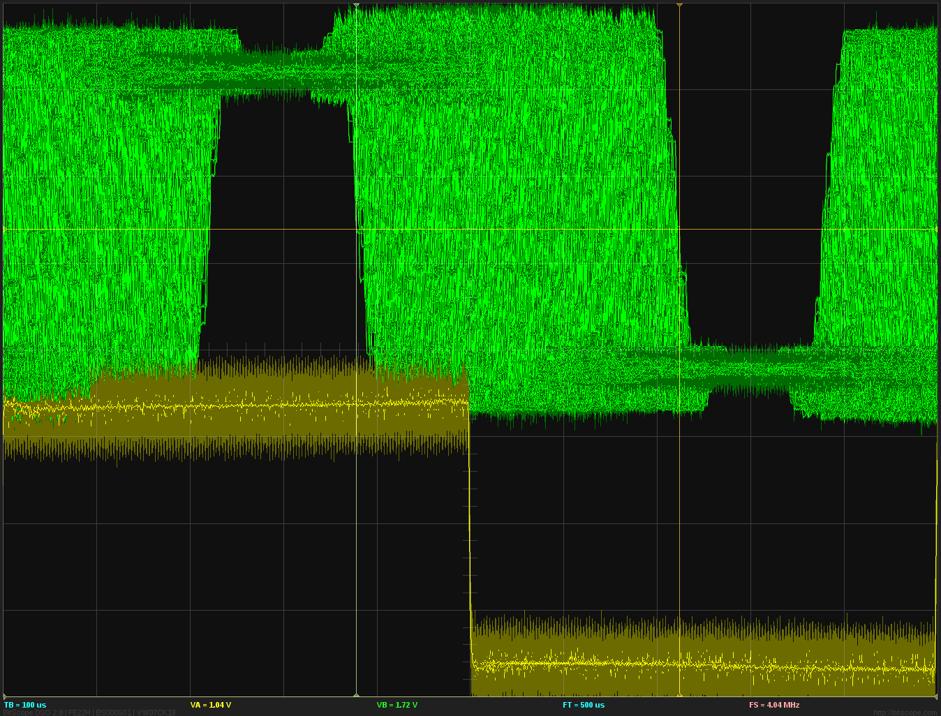 | 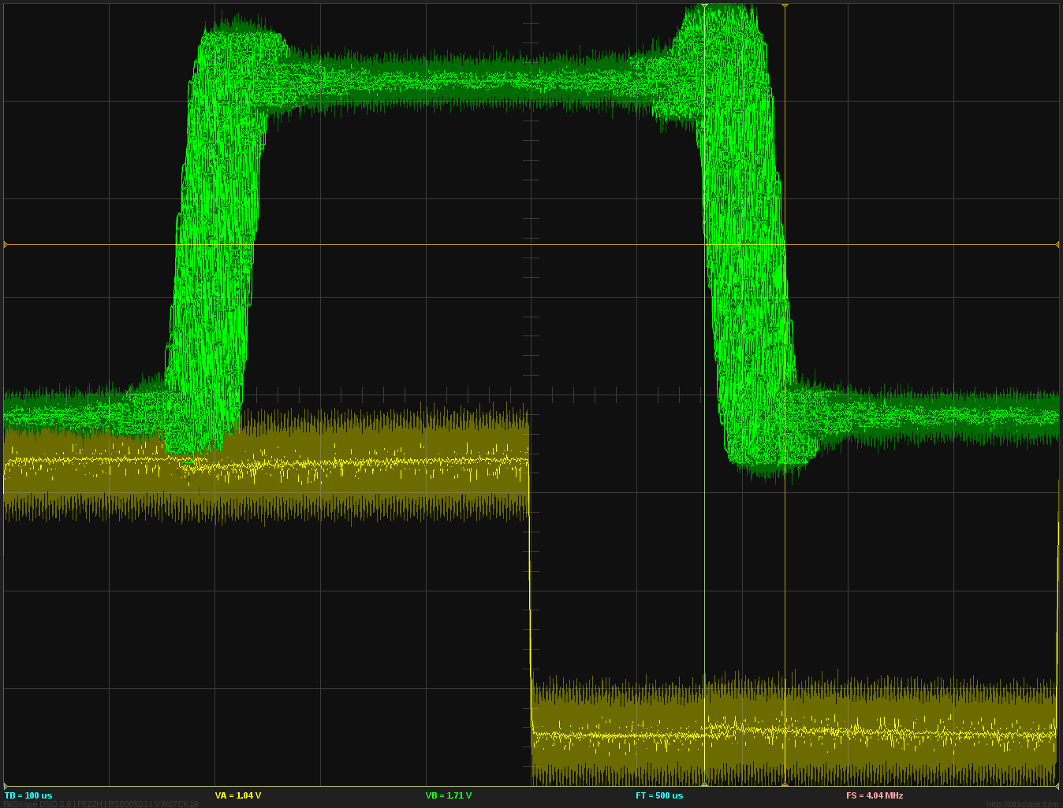
200 ms  275 / 150 μs | 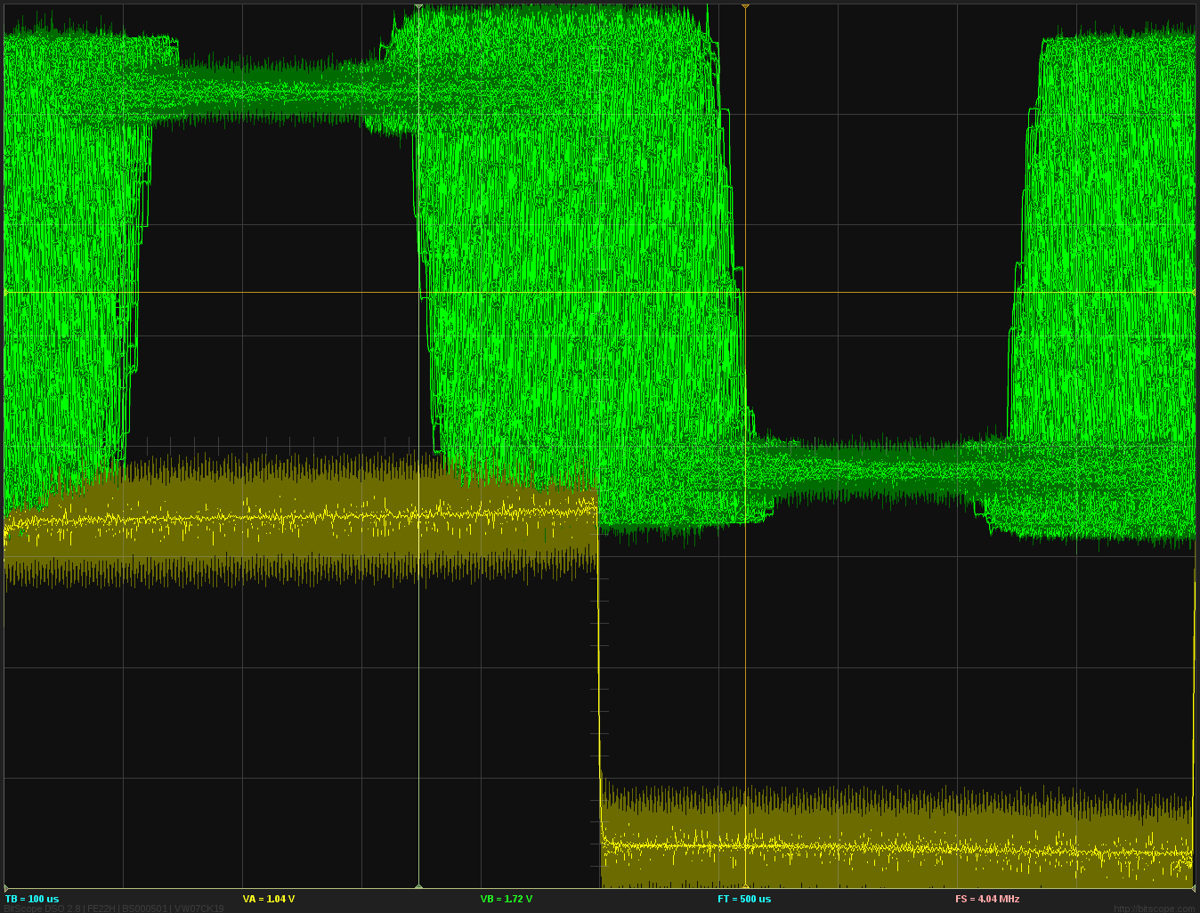 | 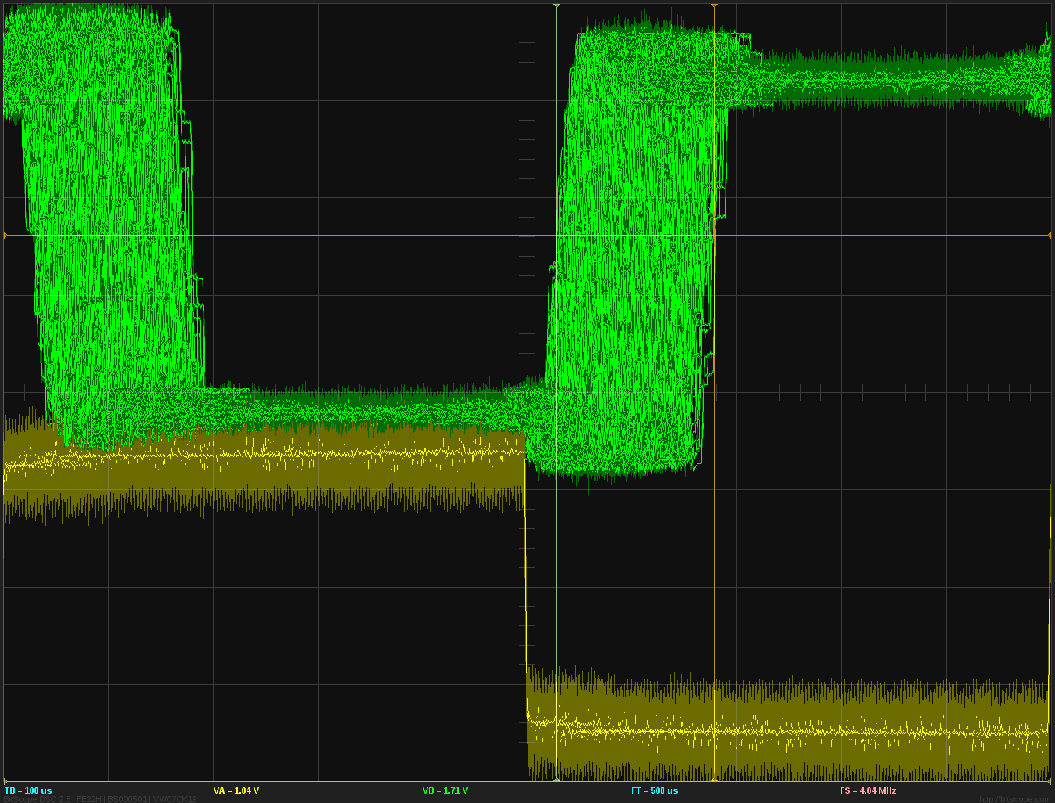
2000 ms  560 / 540 μs | 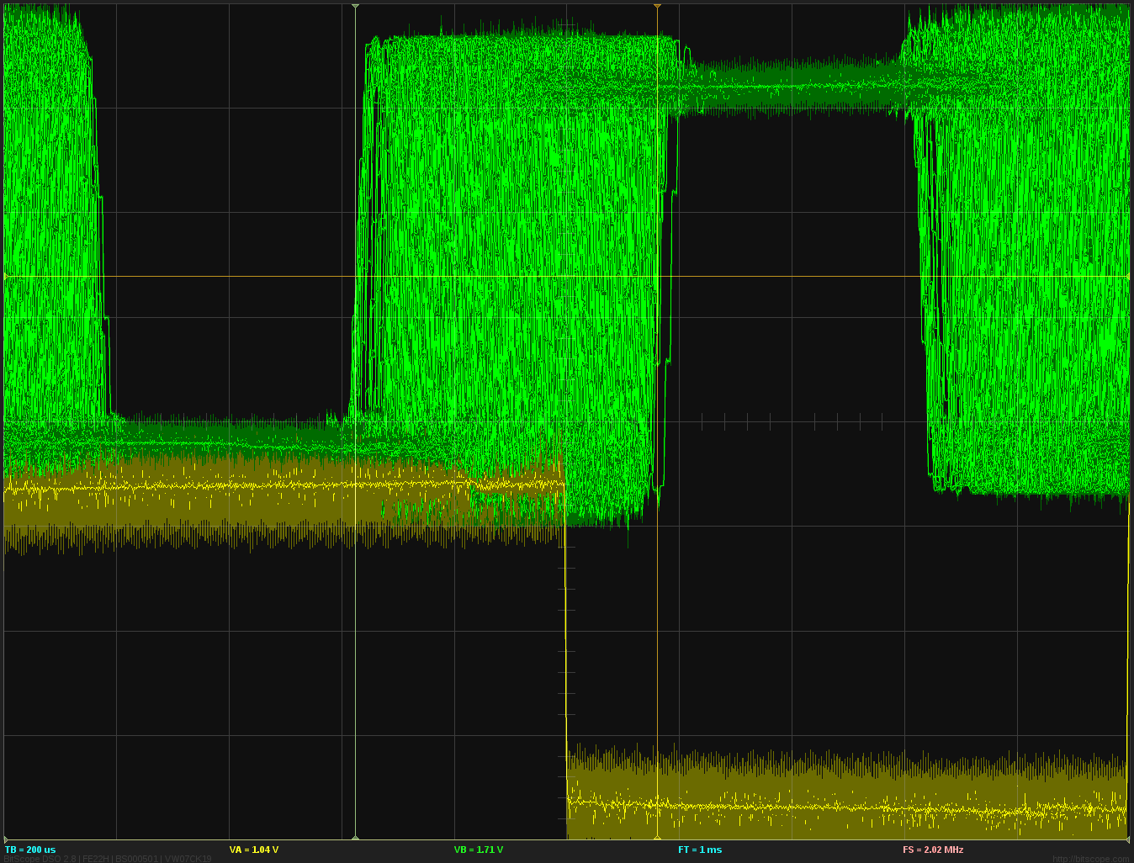 | 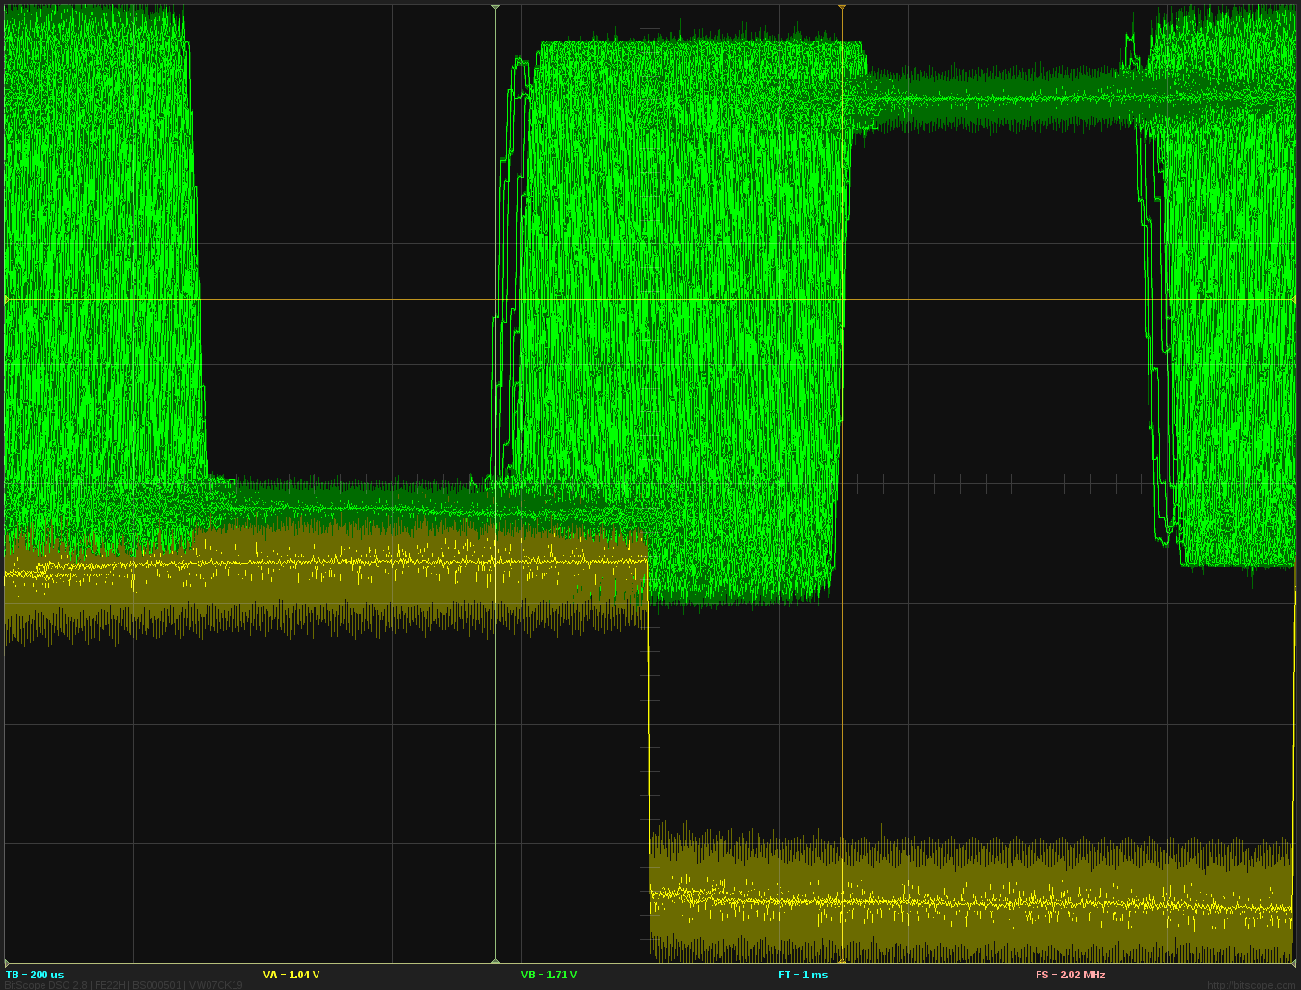
20000 ms  860 / 820 μs | 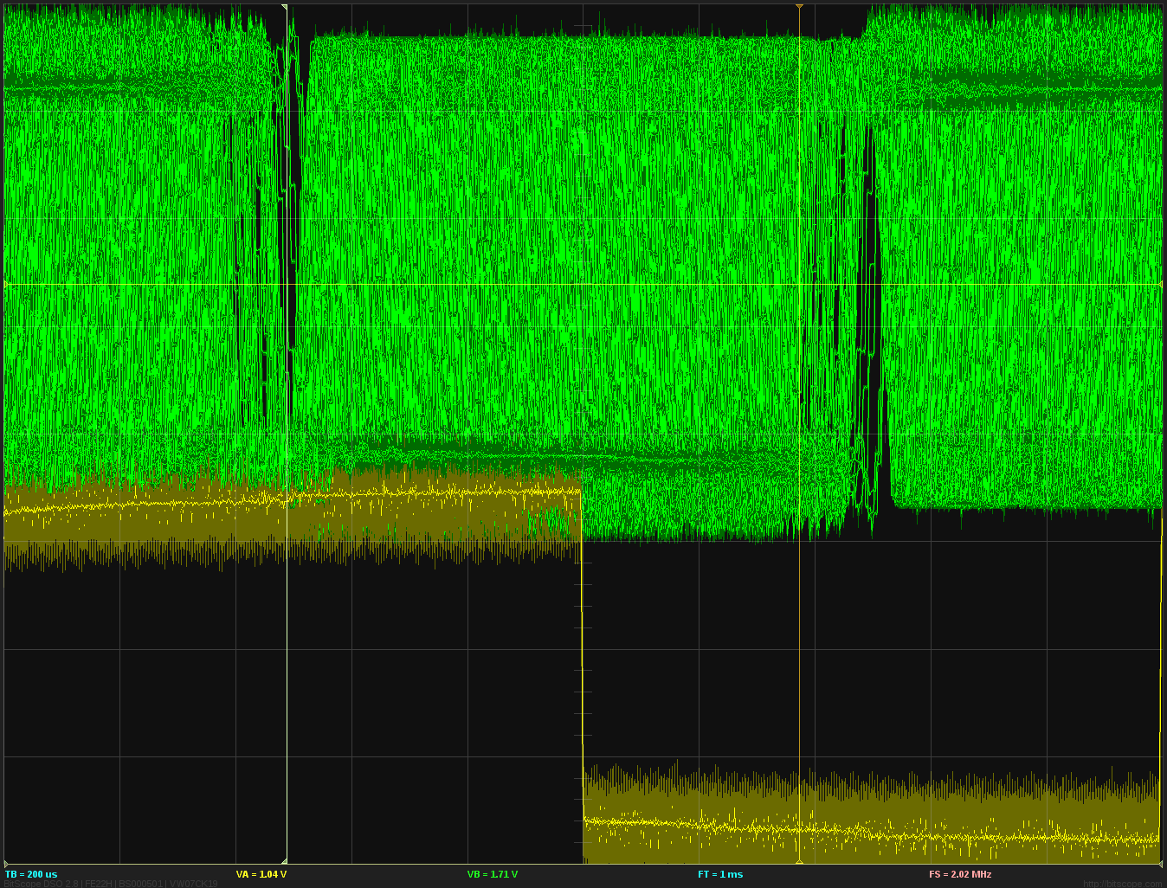 | 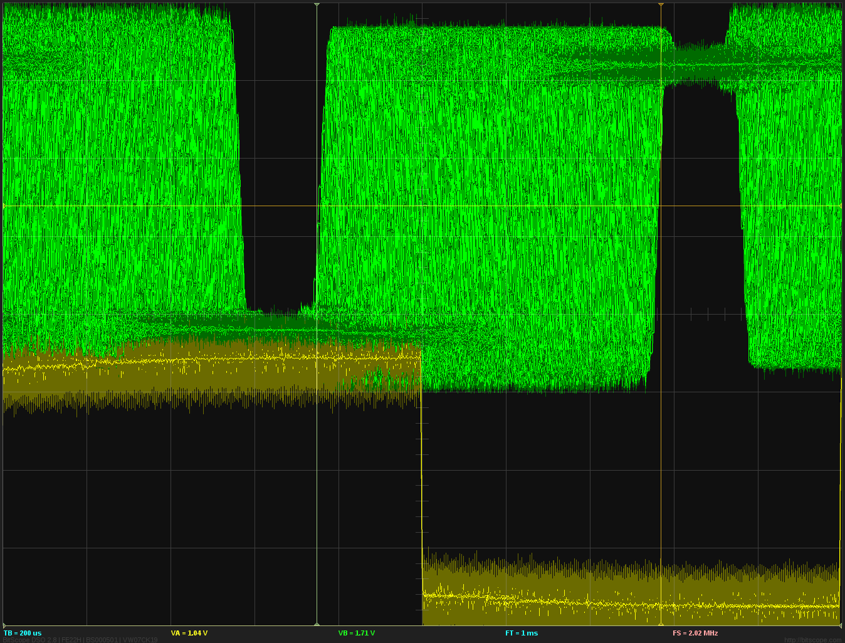

In general, with the combination of the new delay estimation in alsa-sink and alsa-source and the new module-loopback code, results similar to zita-aj bridge could be achieved.
The table below shows a qualitative comparison between module-loopback and zita-aj bridge. The timebase for the screen shots is 100 μsec per division. Recording time was 10 minutes after 1 minute of stabilization for module-loopback using 50 ms as the requested latency and 500 ms adjust time. For zita-aj bridge only about 5 minutes could be recorded, because zita-aj bridge stopped working on the test system after a while. For all combinations, the latency is kept stable to better than ±50 μsec of the target latency. The appearance of multiple lines in the HDA to HDA case is due to the source signal instability described above.

 | zita-aj bridge | module-loopback
USB → USB | 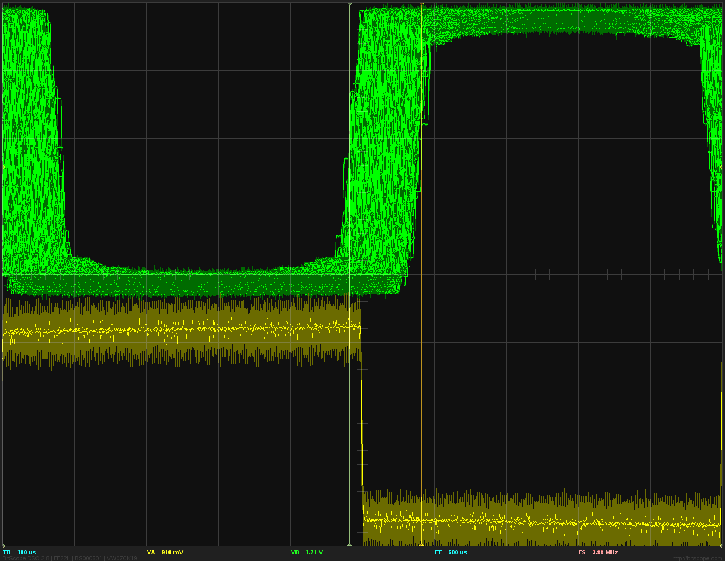 | 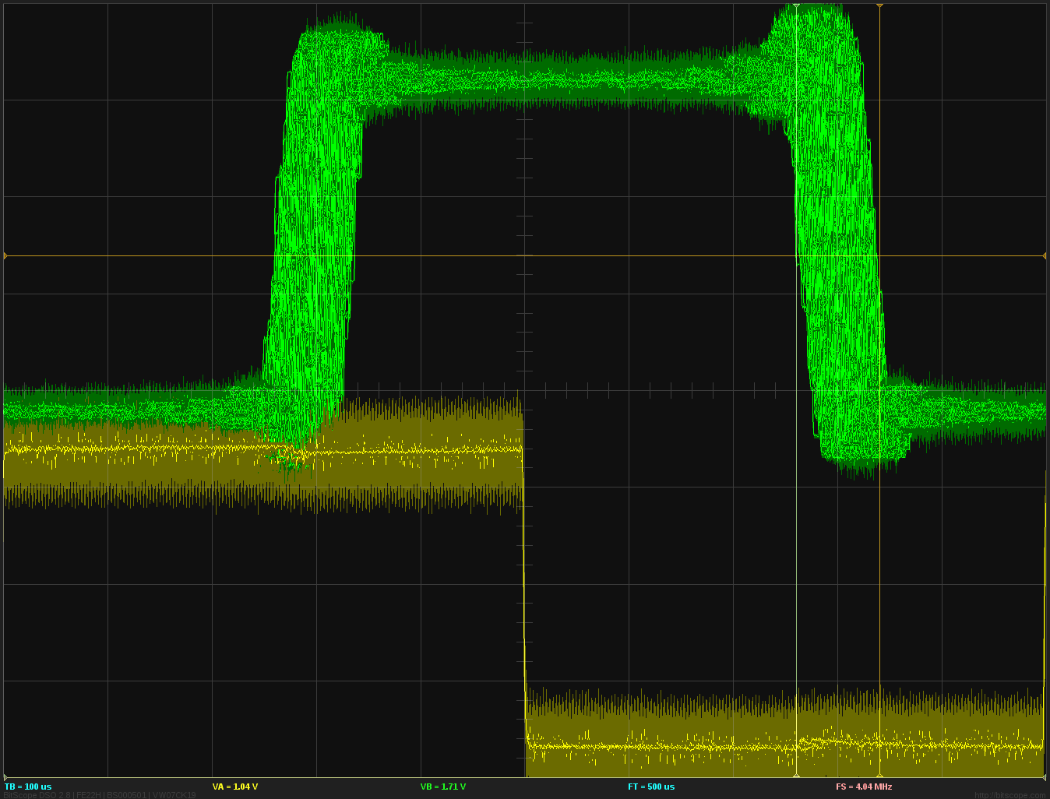
USB → HDA | 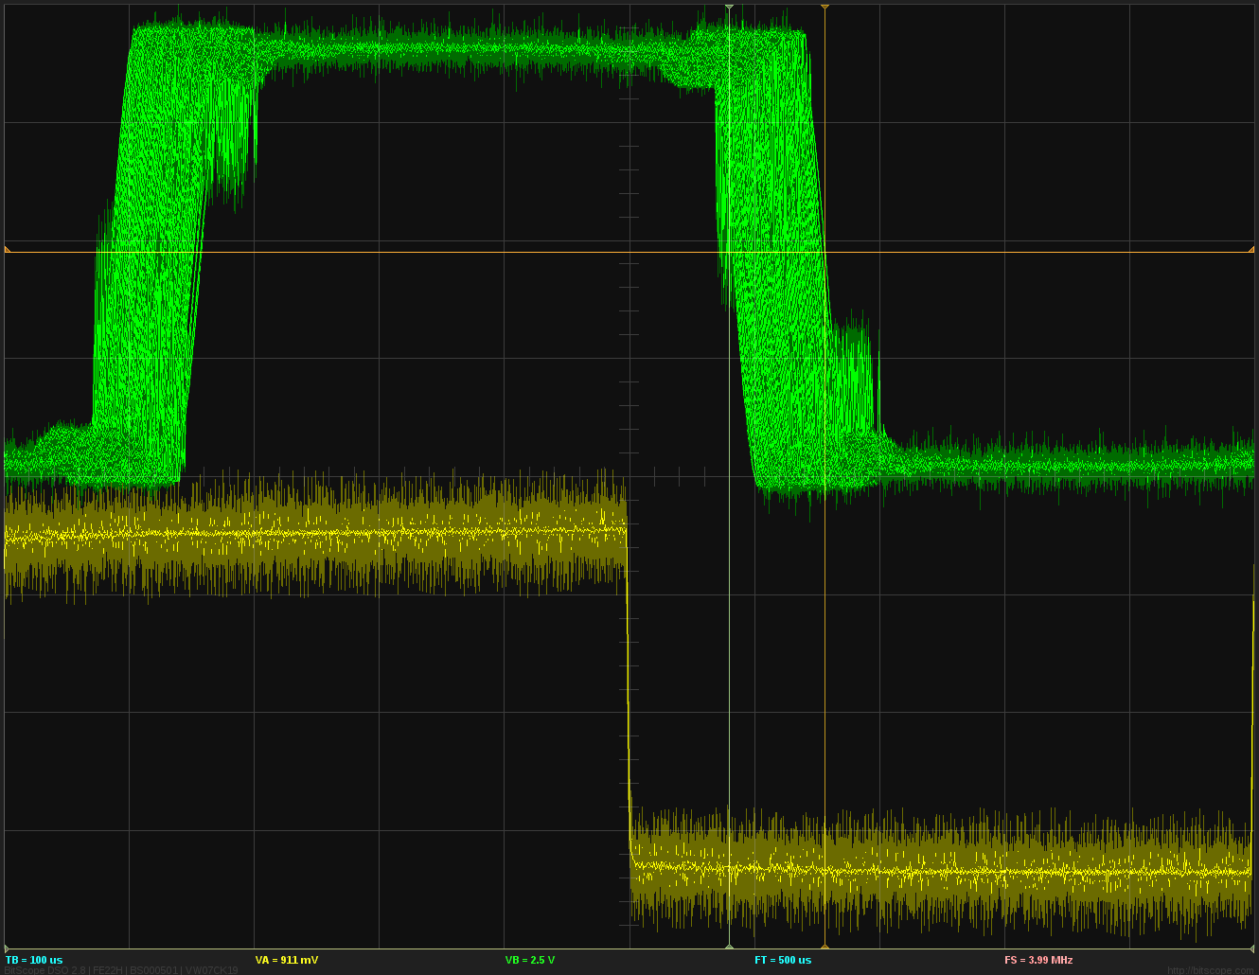 | 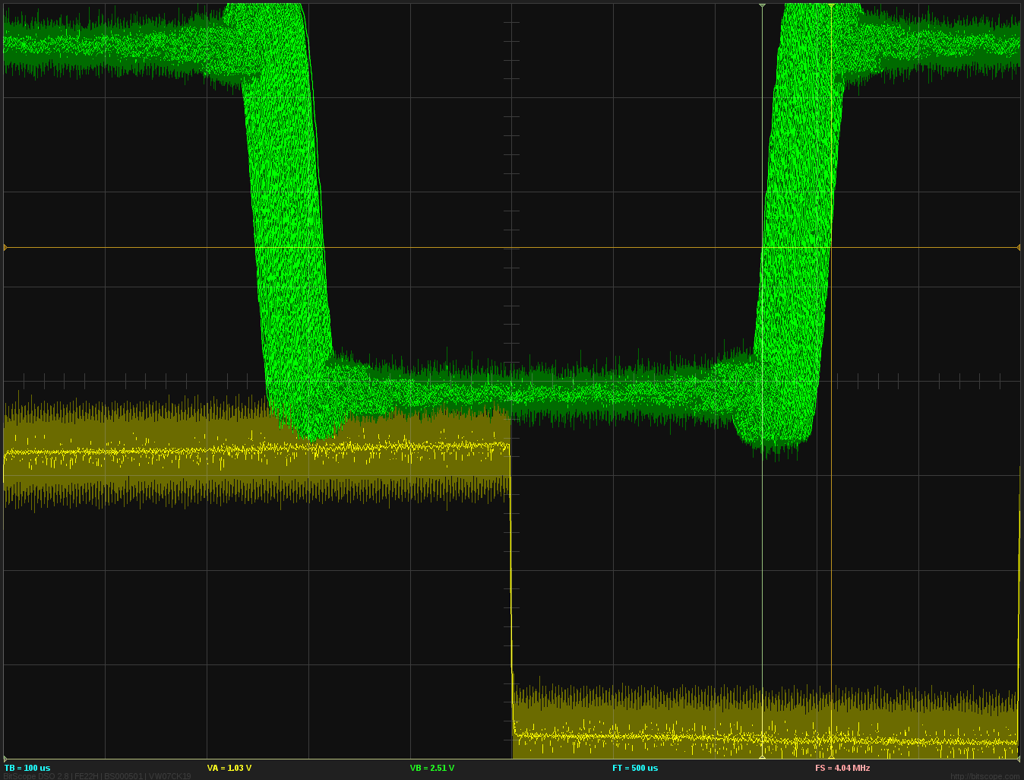
HDA → HDA | 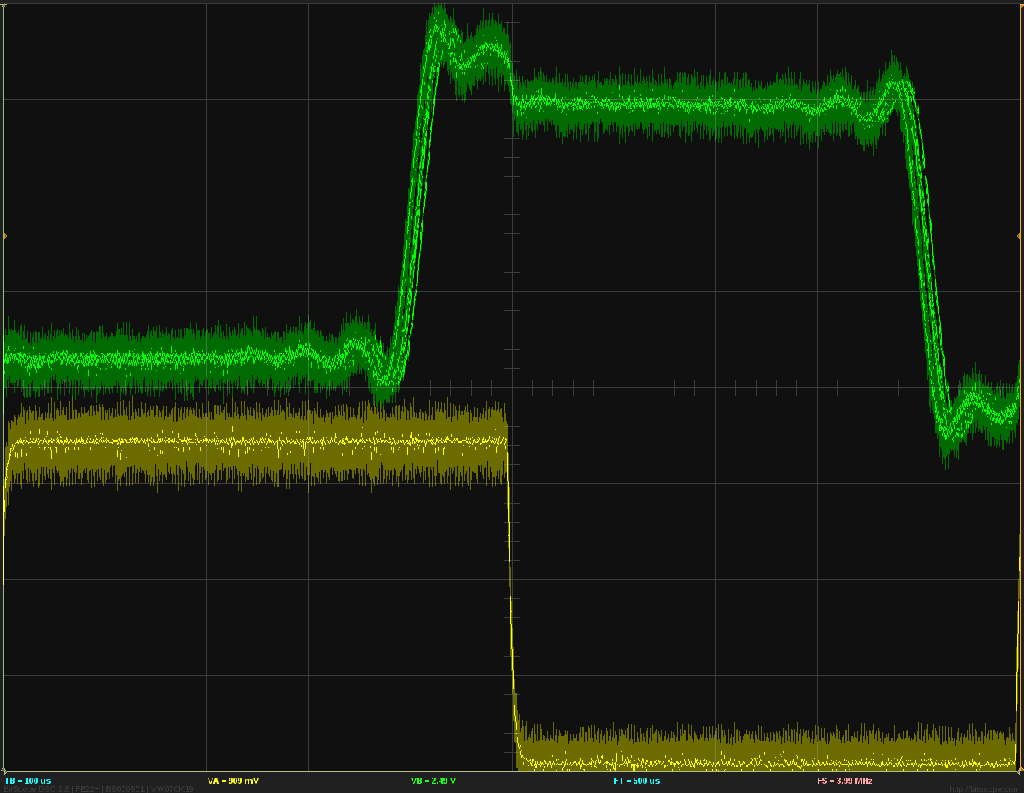 | 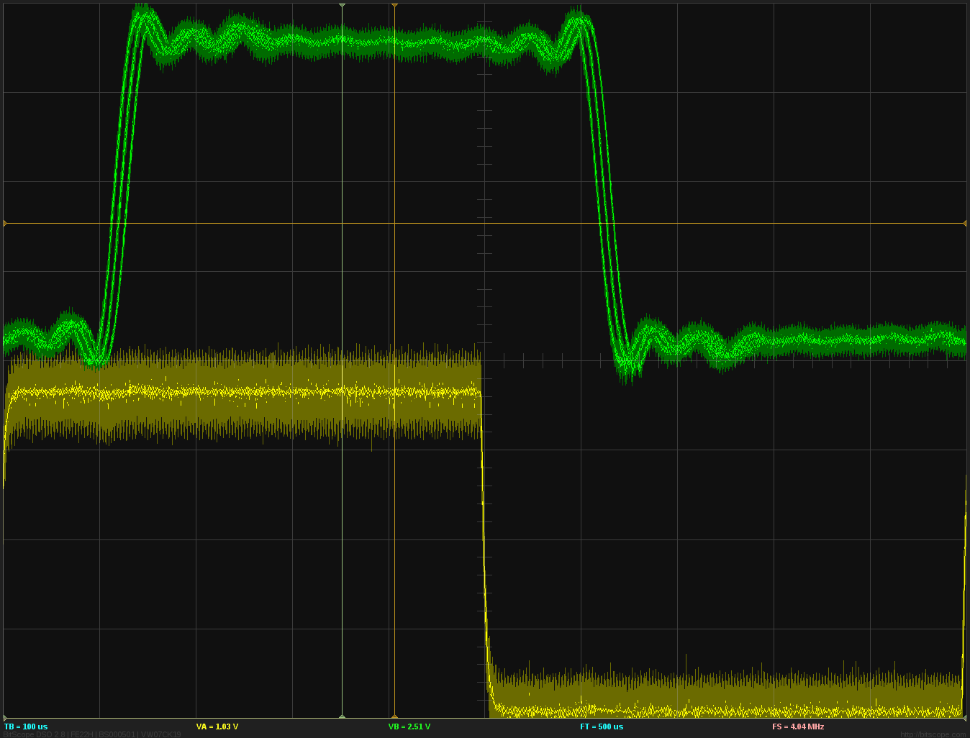
HDA → USB | 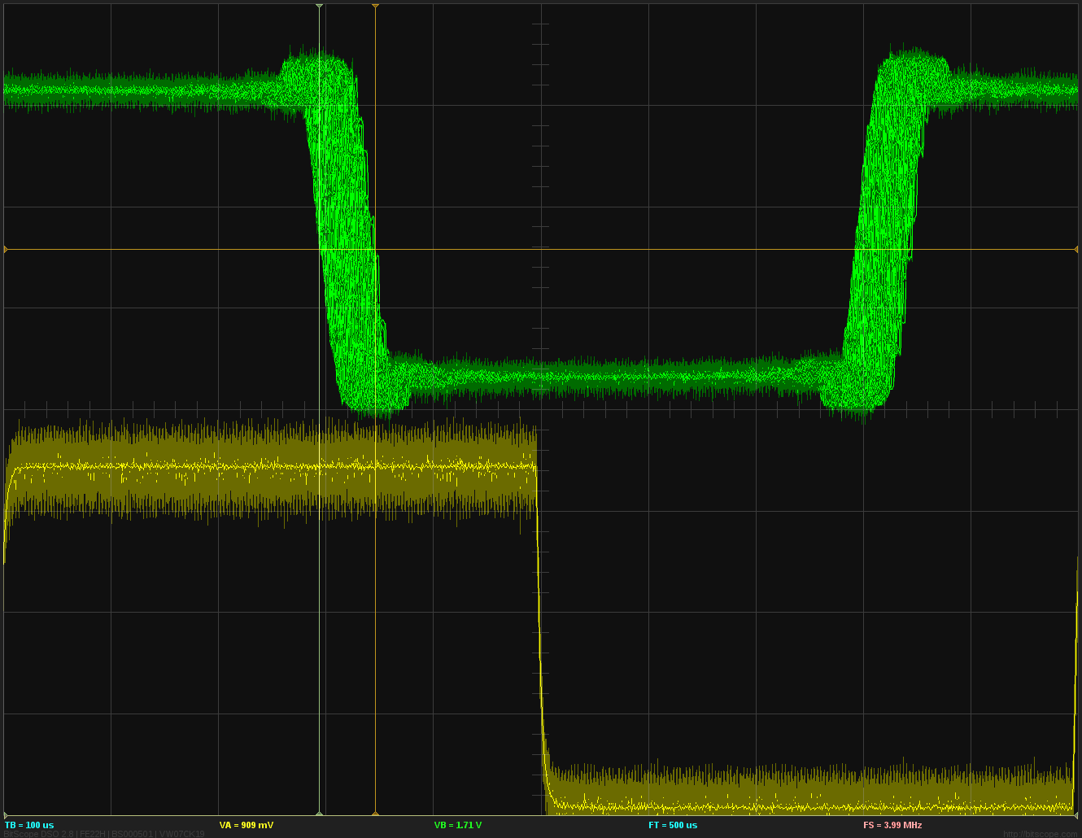 | 

